**Course Number: AIT 524**

**Shane Armstrong**

**Week 11 Homework Assignment 10 Joins**

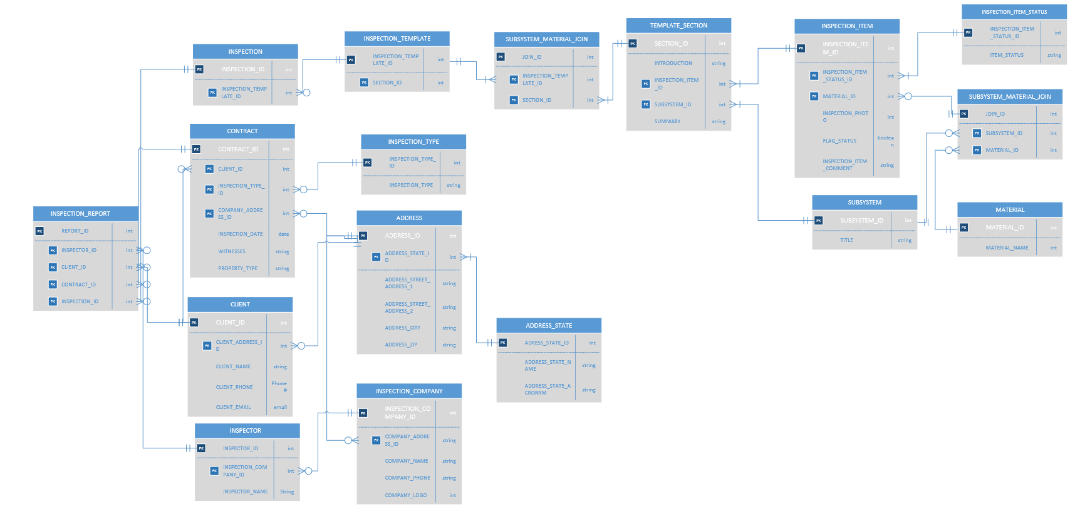

Write four SQL queries to join two or more tables where each query contains multiple combined single-row functions. Explain what each query is intended to do.

1. Query mixed case names of all clients and their emails

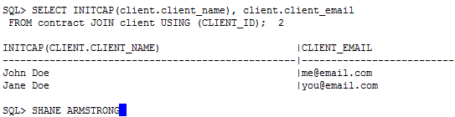

1. Query mixed case names of all clients and their domains

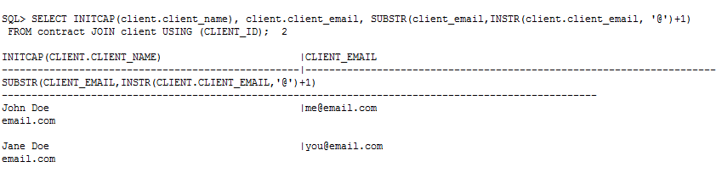

1. Query clients and the time since their inspection

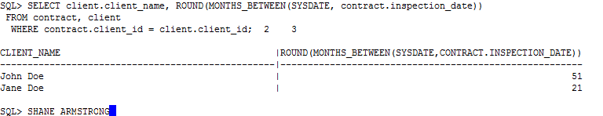

1. Query clients and their inspection dates that have a email domain of ‘email.com’ and that has been done in the last 2 years.

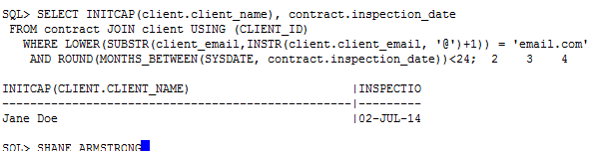

1. Select the latest inspection dates based on different property types

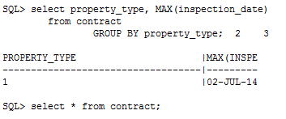

1. Select the latest inspection dates based on different property types that was witnessed by the inspector

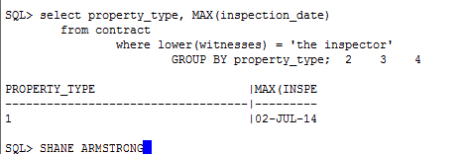

1. Select the latest inspection dates based on different property types that was witnessed by the inspector and taken place before 2015.

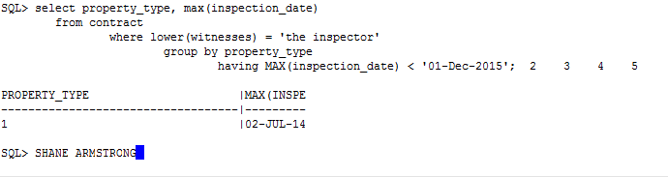

1. Count the number of states serviced by property type

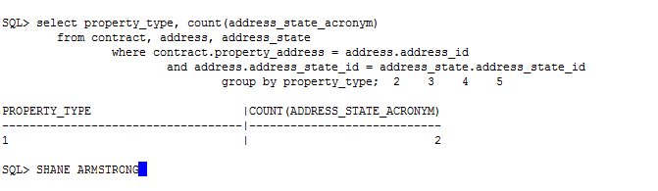

1. Count the number of states serviced by property type within the last two years

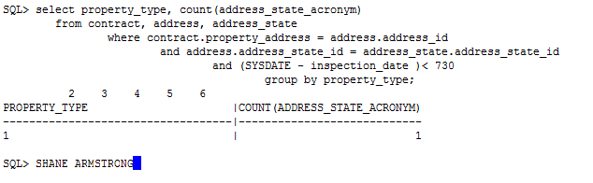

1. Count the number of states serviced by property type within the last two years that have been serviced in at least one state

